Introduction
Performing an assessment is an exciting opportunity to gain more information about the horse’s mental & physical status. Learning goals:
- Train your senses
- Increase your understanding
- Detect changes early on
- Assess load capacity
- Assess trainability

Basic structure
To keep oversight, each assessment should follow a logical structure:
- General information
- Observation (static)
- First Palpation
- Observation (dynamic)
- Second palpation

Overall markers
During the entire assessment, you check the presence / absence of the following makers:
- Pain / Stress / Discomfort signals
- Abnormal posture
- Altered gaits
- Soft tissue development
- Stiffness / reduced mobility

Next to structure comes order. It doesn't matter what order you choose if it is consistent throughout all your assessments. Examples include:

- Left to right - front to back - top to bottom
- Right to left - back to front - bottom to top

Copyrights
Please take note that the content of this manual is copyrighted by Thirza Hendriks. It is strictly forbidden to change or publish this document online or distribute to third parties without the explicit written consent of Thirza Hendriks herself.

Disclaimer
This document has been compiled with great care to ensure the accuracy of the information. Thirza Hendriks cannot be held responsible for incorrect information in this document, or any damage caused by incorrect use of this information. This document does not replace veterinary diagnosis and no definite medical conclusions can be drawn from this document.

General information
To get started, collect the horse’s general information with regards to personal data, management, and training regime.

Date

Author
Country
Horse

Breed

Age

Sexe

Pedigree

INSERT HORSE’S PICTURE HERE
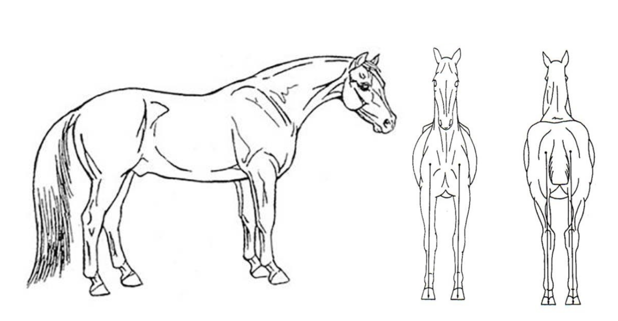

Management
Gather information on the general management of the horse as specified below.

Stabling / turnout ratio
What type of surfaces?

Daily diet
Dentist
Last visit; any issues noted?
Hoof care
Barefoot or shod? Intervals?

Bodywork sessions
What type and intervals?

Worm management
Last faecal count / dewormer?

General habits
A horse has many habits that are essential for its survival. They roll, chew, graze, run and rest. Observing these natural habits will tell you more about its ability to perform these natural habits and with what level of balance. Below you’ll find the tasks specified on what and how to observe.

Rolling pattern
Can he/she roll over?
Are the limbs tucked in?

Chewing pattern
Left / right symmetry

Grazing vs browsing pattern and ratio

Resting pattern
Does he/she rest often?
Is it always the same limb?

Training
Consider the horse’s current workload. If the horse is currently not in training, then please just fill in the personal agenda of the horse, I.e., how its regular week is structured in terms of handling and activities.

Main Discipline

Please summary your current training schedule (last 3wk)
Include:
Current focus of the training
How many times a week?
+/- duration of a session?
Ratio groundwork vs ridden
What gaits used?
Variation intervals
Training Surfaces

Are there any performance problems / struggles?

Equipment used

Medical history
When relevant, please fill in the horse’s medical history. Injuries include events after which the horse seemingly looked alright such as a pullback trauma, a fall where the horse immediately got up again without external blemishes or lameness seemingly visible.

Known injuries / accidents

Known pathologies; malformations

Medication (if relevant)

Bodily observation
Apart from the general habits, you can also observe confirmation and posture. Confirmation is everything related to the skeletal framework of the horse – and therefore cannot be altered – whereas posture relates to how the horse arranges itself – and thus can be changed. During observation, it is useful to ask the horse to square up as much as possible. However, don’t force it if the horse shows discomfort or struggles to do so – in the latter case, consider this as valuable information in the assessment process.
Observe the horse in a comfortable environment. Take at least 2 meters distance and walk around the horse observe it from all possible angles:
- Front – back view
- Lateral view
- Top view

Below you can find some key areas to assess, first starting with an overall scan and then going more into details.

First overall impression
First impressions count. Before going into details, consider some overall markers to determine first impression.

Level of relaxation / comfort
Does the horse appear comfortable?
Are there any pain or stress symptoms?

First impression of overall posture?

Segmental observation
Skin Scan
Blemishes; scars; wounds or fat deposits?

Overall Posture Scan
Head and Neck Position
Limbs & Feet stance
Overall (a)symmetry scan:
Shoulder-Pelvis Ratio
Left Right differences
Topline underline differences
Thoracolumbar spine
Straight back or deviations?

Muscle toning / linings

General health assessment
A physiological assessment consists of measuring the horses’ vitals.
Resting heart rate
Normal = between 25-40 p/m
Abnormal = > 45

Respiration rate
Normal = 8-15 breaths p/m
Abnormal = > 20

Temperature
Normal = 37 – 38.5 Celsius

Capillary refill time
Pinch your finger on the horse’s gums for 2 s. watch how quickly the white mark returns to normal. Normal = Less than 2 seconds
Abnormal = > 3 seconds

Hydration
Pinch some skin on the neck and see how quickly it returns to normal. Normal = 1-2 seconds. Abnormal > 3 seconds
Mucus membranes
Normal = Pink / Bubblegum colour
Abnormal = white, red or blue (purple)
Ulcers points & gut sounds
Normal = sounds every 45-90 seconds

Palpation
Palpation is the process of feeling and observing the subsequent reaction. So be careful to NOT use any pressure from your hands, fingers or nails and keep close eye contact with your horse while ensuring to prioritise your own safety. It’s not about massaging or manipulating, just feeling what is there or what is not. Go from left to right side and ALWAYS compare both sides.
Try to square up the horse as much as possible to test for symmetry, but never force it.
Give the horse some rest or movement in between when the horse asks for it. Always monitor reactions and keep checking with the horse: you want to work with the horse and not do something to the horse. NEVER go against a brace. Remember, the more you listen the more a horse tells. So, if you feel a horse bracing against a certain direction or movement in general DO not force it but consider it as useful information.

From palpation, you can continue with a few checks for mobility and range of motion. Always be soft and careful and do not over-ask or over-stretch as then you risk tearing up muscle’s fibres. Below you can find some key areas to assess.

General palpation

Overall skin scan:
Any temperature differences, irregularities, swellings, wounds, or fat pockets?

After you’ve done an overall palpation scan, you can assess different body segments more in detail. Consider their feeling separate as well as in relation to the other body parts.

Segmental palpation - head

Teeth & Mandible
Incisors aligned?
Can the jaw move evenly?
Muscle symmetry & development
Hyoid
Is it in the middle?
Can you move it easily?
TMJ
Any reactions?
Overall (a)symmetry
Ears
Tight or floppy?
Mobile at the base?
Parotid glands
Normal or swollen?
Retromandibular space l/r

Segmental palpation – neck
Poll
Muscle development & symmetry
Bony landmarks (osseous)

Skin & Fascia
Turgor test
Top-line / underline mobility

Muscle development
Hyper vs atrophy; (a)symmetry

Joint ROM
Passive & Active
ADVANCED only

Segmental palpation – shoulders
Muscle development & symmetry

Mobility sternum- whither rocks
Left – right and forward – backward

Segmental palpation – front limbs
Upper limb muscle development
& symmetry

Joint surfaces & mobility
Joint mobilisations
ADVANCED only

Tendons & Ligaments
Any swellings? Reactions?
Feet
Medio-lateral balance
Toe length
Bar & heel height
High heel low heel?
Cartilage (sidebone?)

Thoracolumbar spine & ribcage

Muscle development & symmetry

Osseous palpation
Dorsal spinous processes
Lateral surfaces of ribs
General mobility
Wither rock
Ribcage rock

Segmental palpation - hindquarters
Muscle development & symmetry
Osseous palpation
Pelvic points
Tail bones
Joint mobilisation
LS movement (F/E)
Tail movement

Sacro-sciatic ligament
Anal symmetry
Segmental palpation – hind limbs
Upper limb muscle development & (a)symmetry

Joint surfaces & mobility
Proprioception tests
Joint mobilisations
ADVANCED only
Tendons & Ligaments
Any swellings? Reactions?
Feet
Medio-lateral balance
Toe length
Bar & heel height
High heel low heel?
Cartilage (sidebone?)

Movement
To assess movement, it is best to evaluate the horse both in its natural environment as well as in controlled environment (clinical evaluation). Ideally, the movement is assessed on various surfaces and inclinations:

- Soft surface
- Hard surface
- Small hill
Try to assess movement and write down what you see without diagnosing. So, for example, consider stating you see an asymmetry in stride length with the right limb shorter and refrain from sentences such as ‘’the horse is lame’’.

Overall impression

Does movement come easy?

Are there signs of stress, pain, or discomfort?
Overall balance
Sling systems, posture, spine,
and recoil system

Walk & trot – straight line
Ideally assess on both soft & hard surface and write down any potential differences between the two.

Front view:  - Head and neck movement  - Tracking up | Walk:  Trot:
Hind view:  - Pelvic movement  - Tail carriage  - Ribcage rotation  - Tracking up  - Sole presentation  ADVANCED: joint movement  Hip, hock, and stifle | Walk:  Trot:
Lateral view:  - Breathing  - Stride length (symmetry)  - Gait purity  - Muscle linings  - Shoulder movement  - Toe / heel landing  Advanced: joint movement  Elbow, carpus, fetlock, LS joint, stifle & hock | Walk:  Trot:
Transitions
Are the transitions from walk to trot smooth? What changes?

Walk & trot – circles and figures of 8
Spinal alignment & ribcage rotation

Tracking up of the limbs

Balance & proprioception

ADVANCED: Joint movement

Backwards

Can the horse shift its weight from front to hind end?
Is there a clear diagonal pairing?
Can the horse coil the loins, or does it struggle?

Is the back-up straight or crooked?

Incline – small hill up and down
Balance & weight division:
Uphill: pushing or pulling? Downhill: braking activity hind limb? Thoracic sling balance control?
Elbow stability
Is there a double clunk?
Head and neck movement: passive or active?

Bonus – Canter
Transition quality

Loin coiling ability

Gait purity
(suspension & beats)

Second palpation

After the movement you can come back to palpation to check for heat changes as well as changes in swellings and ROM of certain joints of interest to determine whether movement is a good influence of not.
Heat & Swellings:
Improved or not?
Joint ROM & tissue softness:
Improved or not?

Overall end evaluation

Summarize the assessment below and consider:

What did you learn from this assignment?

- What did you find easy / hard?

The load capacity trainability of the horse

The horse's strengths and weaker areas

Priorities for improvement

Finally, consider whether the horse changed throughout assessment? I.e.,
is the horse the same, better, or worse after the assessment in terms of biomechanics and mental state.

